**Integration Using the Trapezoidal Rule :**

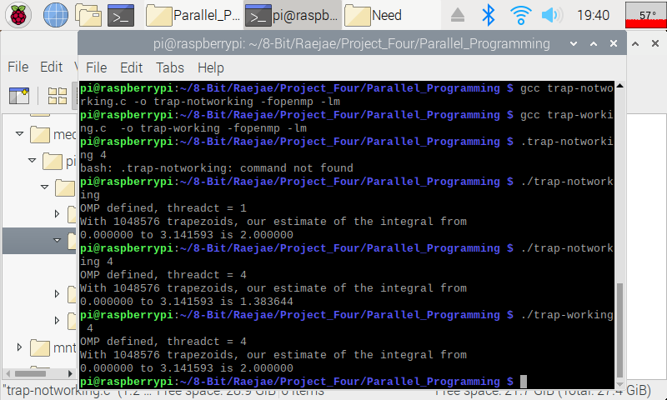For this application I ran both to compare but ran into errors initially and also discovered some new things. The first thing is that the activity didn’t make reference to the Math Library which is why compiling brought forth errors. The other issue is when ran on one core (discovered by accident) we will get our intended answer but multiple don’t give us (2). We initally had integral shared across the forked threads so we ran into issues like this; however, declaring as a pattern fixes this problem.

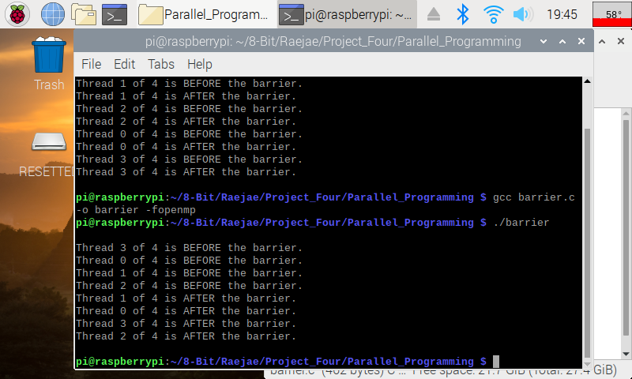**Barrier Program**

If we look closely, we can see that in the initial run the treads were executing really out of sync and there was no management function in place. We notice after uncommenting Pragma that the threads are all aligned before and will wait before execution which manages our program much more efficiently.

**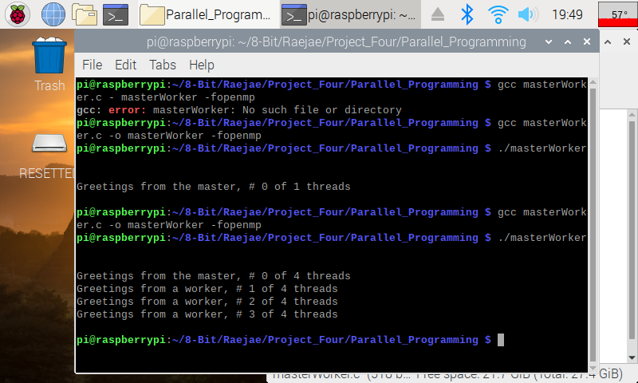  
Master Worker:**

I made an error in loading this however, it was just a typo and after running we can see that we only get one thread returning “Greetings.” We want our program to run in parallel so after uncommenting we notice we receive a message from each thread.